#RealKnowledge Twitter Chat Highlights: Nia Shanks - June 2013

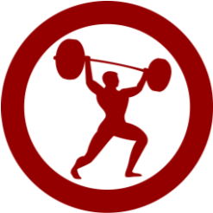
Thanks to Nia Shanks for taking the time to answer reader questions in our June Twitter chat! Here are some highlights from the conversation for those who missed it.
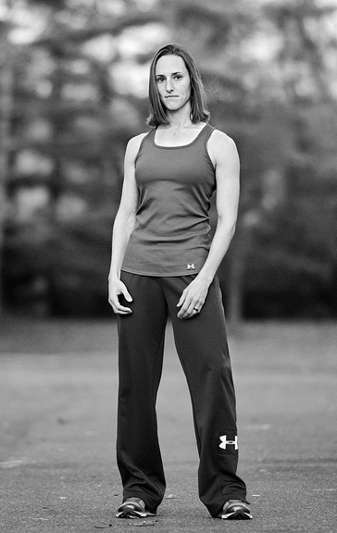
- Should guys be okay with “lifting like a girl” too?
Of course. It’s more about an attitude and mindset than anything else.

- Tell us a little about your approach to nutrition.

Always simple, flexible, and whatever works best for the individual. There’s no one-size-fits-all for anyone. When it comes to nutrition, I prefer a few simple, flexible guidelines and follow 90/10 principles.

- What are the best alternatives to squats and lunges if you have knee issues?

I like step ups, rear foot elevated split squats, goblet squats, and trap bar deadlifts to name a few. If single leg exercises make it worse, I like goblet squats.

- Why is it always about the way you look – shouldn’t things be about being a better you?

See this tutorial for more info: http://www.niashanks.com/tutorials/train-to-be-awesome-guide/

- For beginner and older obese individuals, what strength exercises do you recommend?

I focus on movement over specific exercises but my favorites are goblet squats, rack pulls, push ups, and inverted rows. It comes down to finding what works for each individual, but still focusing on certain movements with appropriate variations. Compound exercises, proper form, and progression are what I focus on.

- Any tips for handstands/handstand push ups?

Master handstand holds first, then progress to pike push ups, feet elevated, then negatives. Video showing this progression here: http://www.youtube.com/watch?v=rEgqIEQcF20&feature=youtu.be

- Any tips for improving your deadlift?

Discover your weak links (weak off the floor or top) and address them. If trainees are weak off the floor I like using a 2 inch deficit for a training phase.

